Paper Title(16 times new roman bold)
Author name1 , affiliation
Author name2 , affiliation
Author name3 , affiliation
Corresponding Author email: (12 times new roman regular)
Paper history (accepted: , received)
This article is open-access under the CC BY 4.0 license (http://creativecommons.org/licenses/by/4.0/)

Abstract
An abstract is a short summary of your (published or unpublished) research paper, usually about a paragraph (c. 6-7 sentences, 150-250 words) long. A well-written abstract serves multiple purposes:
- an abstract lets readers get the gist or essence of your paper or article quickly, in order to decide whether to read the full paper;
- an abstract prepares readers to follow the detailed information, analyses, and arguments in your full paper;
- and, later, an abstract helps readers remember key points from your paper.
It’s also worth remembering that search engines and bibliographic databases use abstracts, as well as the title, to identify key terms for indexing your published paper. So what you include in your abstract and in your title are crucial for helping other researchers find your paper or article.
Keyword:word1,word2,word3,…(10 time new roman italic)
Introduction(12 time new roman bold)
The introduction is your opportunity to show readers and reviewers why your research topic is worth reading about and why your paper warrants their attention.
The introduction serves multiple purposes. It presents the background to your study, introduces your topic and aims, and gives an overview of the paper. A good introduction will provide a solid foundation and encourage readers to continue on to the main parts of your paper—the methods, results, and discussion. (12 time new roman regular)
Methods section(12 time new roman bold)
The methods section is simultaneously the easiest and the most important section to write accurately. Any results in your paper should be replicable based on the methods section, so if you've developed an entirely new experimental method, write it out in excruciating detail, including setup, controls, and protocols, also manufacturers and part numbers, if appropriate. If you're building on a previous study, there's no need to repeat all of those details; that's what references are for.
One common mistake when writing a methods section is the inclusion of results. The methods section is simply a record of what you did.
The methods section is one example of where knowing the journal is important. Some journals integrate the methods section in between the introduction and the results; other journals place the methods section at the end of the article. Depending on the location of the methods section, the contents of the results and discussion section may vary slightly.

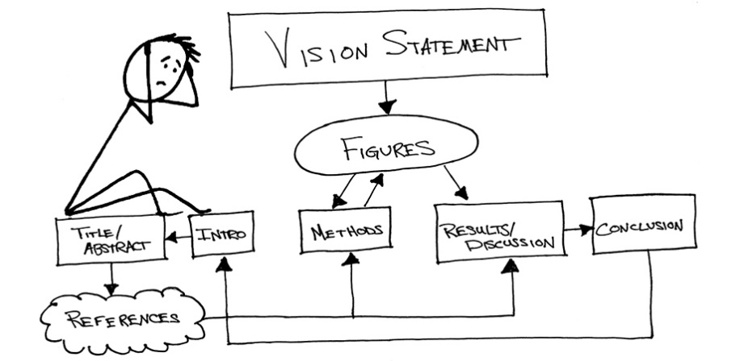
Fig.1(the figure should be left align 10 time new roman regular)
A. subsection
Any subsection title should be numbered alphabetically and the font (11 time new roman italic the title and the rest of the paragraph 12 time new roman regular)
Table 1:this is the caption of table (10 time new roman regular) should be left align
Title1 | Title1 | Title1 | Title1

Results and Discussion Section
results and discussion are separate sections. However, the trend is to merge these two sections. This section should form the bulk of your paper-by storyboarding your figures, you already have an outline!
A good place to start is to write a few paragraphs about each figure, explaining: 1. the result (this should be void of interpretation), 2. the relevance of the result to your hypothesis statement (interpretation is beginning to appear), and 3. the relevance to the field (this is completely your opinion). Whenever possible, you should be quantitative and specific, especially when comparing to prior work. Additionally, any experimental errors should be calculated and error bars should be included on experimental results along with replicate analysis.
You can use this section to help readers understand how your research fits in the context of other ongoing work and explain how your study adds to the body of knowledge. This section should smoothly transition into the conclusion.
Conclusion
In the conclusion, summarize everything you have already written. Emphasize the most important findings from your study and restate why they matter. State what you learned and end with the most important thing you want the reader to take away from the paper-again, your vision statement. From the conclusion, a reader should be able to understand the gist of your whole study, including your results and their significance.
References
The references use APA style format you can use endnote software or mendeley reference management software
Author’s Last Name, First Initial. (Year). Article title. Magazine/Journal/Newspaper Title, Volume number(Issue number), Page numbers. doi or URL of publication home page

