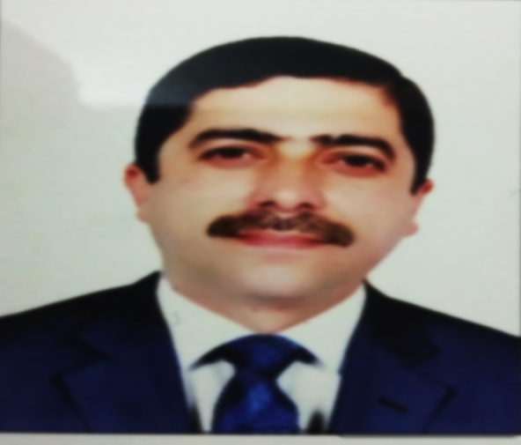

VITA

Full name and Surname | Nameer Fadhel Gaeab AL-kalifa
Place and date of birth | Baghdad –al resafaa  4/11/1967 | Home address | Diyala/baquba
Nationality | Iraqi | Religion | Muslim
Graduation Year | 1991 | University/College | University of musol  College of Medicine
general specialization | MBCHB | Specialization | HUMAN ANATOMY  Human histology  Human embryology
Job | Faculty member | Current work address | University of Diyala/College of Medicine
First job date | 20/06/2006 | First job place | University of Diyala/College of Medicine
Phone Number | 07705856658 | E-mail | nameer@uodiyala.edu.iq

 | Education
Degree | Field | University/College | Year
B.Sc. | Medicine and surgery | University of musol/College of medicine | 1991
M.Sc. | Human anatomy / human histology /human embryology | baghdad University/College of  medicine | 2011
Ph.D. | Human anatomy / human histology /human embryology | University of al-nahrine/College of medicine | 2015

Title of Doctoral Dissertation and Master's Thesis
Master Thesis | Arabic | دراسة المشيمةِ في الحملِ الطبيعيِ والمعقّدِ في النساء العراقيات دراسة عيانية ومجهرية
Master Thesis | English | A study of placenta in normal and complicated pregnancies in Iraqi females, macroscopical & microscopical studies.
Doctoral Dissertation | Arabic | التغيرات الكيميانسيجية المناعية لدى الفئران الوليدة حديثا للقشرة الأمامية للدماغ بعد التعرض قبل الولادة باستخدام للكيتامين لاختبارات تونيل ومونولديهايد
Doctoral Dissertation |  | Immunohistochemical changes of the new born a rat frontal cortex
 | English | after prenatal ketamine exposure using tunel and malon dialdehyde (MDA) tests.

 | Scientific Title
Item | Scientific title | Year
1 | Assistant teacher | 2006
2 | University teacher | 2015
3 | Ass. Prof. | 2019

 | Teaching Experience
Item | Job | University/College | Year
1 | Faculty Member | University of Diyala/College of Medicine/Department of anatomy | 2005-2013
2 | PhD student at the University of al- naahrine, , 2012-2015.
3 | Faculty Member | University of Diyala/College of Medicine/Department of anatomy | 2015-Present

 |  |  | The subjects he/she taught
Item | Stage | Subject | Year of Teaching | University/College | Department
1 | First | Human anatomy | 2006-2021 | University of Diyala/College of Medicine | anatomy
2 | Second | Human histology | 2011-Present | University of Diyala/College of Medicine | anatomy
3 | Second | Human embryology | 2011-Present | University of Diyala/College of Medicine | anatomy

 | Publications
No. | Paper Title | Date of publication
No. | Paper Title | Month | Year
1 | . " Lymphocytes count, Acute phase protein And Renal function In COVID-19 Patients as Disease Severity Predictors " | 22-23 June | 2021
2 | Evaluation of Morphological (Macroscopic and Microscopic) parameters of placentas in pregnancies complicated by Preeclampsia, Diabetes and Preeclampsia and Diabetes | 02-08 | 2019
3 | MULTIPLANNER MEASUREMENT TO THE CLICKED TEMPROMANDIBULAR JOINT (CONDYLAR PROCESS AND ARTICULAR DICK) WITH CONBEAM COMPUTED TOMOGRAPHY | 09-03- | 2020
4 | Up to Date Clinical Assessment of Squamous Cell Carcinoma of The Larynx in Iraq. | 03, 2020 | 2020
5 | Detection of serum cytokines IL-6, IL-10 and IFN-ɣ in COVID-19 patients as disease severity predictors | December 1st, | 2020
6 | Association of febrile convulsion with serum sodium and hematological indices among Iraqi children in Diyala province | Jan. | 2019
7 | THE DIFFERENCE BETWEEN KETAMINE AND PROPOFOL ADMINISTRATION TO INDUCE APOPTOSIS NEURODEGENERATION IN MICE CEREBRAL CORTEX | 18 Feb | : 2019
8 | Evaluation of Human Epidermal Growth Factor Receptor-2 in Iraqi Women with Breast Cancer | June | 2019
9 | Evaluation the Effect Of Magnetized Water On The Bone Density And Osteoporosis In The Experimental Rats By DXA-Scan | , April | 2019
10 | Immunohistochemical Malondialdehyde Antibodies Changes of the Adult Mice Testes Affected by Prenatal Manganese Chloride Exposure | Vol. 15(1) | 2017

 | Selective Conference, Workshop, Symposium, and Meeting Presentations
Item | Title | Presentation | Place |  |  | Year
1 | Effect of Ambient temperature on Sleep in Mice. | Poster | Biennial meeting of Rhythm in the Southeast Region (RISER), Lexington, KY, Mar 2015. |  |  | 2015
2 | Sleep Regulation as Epilepsy Therapy: a study of the effect of ambient temperature on mouse sleep. | Poster | AES, New York, 2015. |  |  | 2015
3 | Sleep regulation as Epilepsy therapy: A study of the effect of ambient temperature on mouse sleep | Poster | 32nd Annual BGSFN Spring Neuroscience Research Day,  Lexington, KY, April 2016. |  |  | 2016
4 | Effect of Temperature on Sleep Regulation in an Animal Epilepsy Model | Poster | The 38th Annual International  Conference of the IEEE Engineering in Medicine and Biology Society, EMBC2016, Florida. |  |  | 2016
5 | Sleep Modulation in Control and Epileptic Mice Through Ambient Temperature Regulation. | Poster | Sleep meeting 2017, Boston. |  |  | 2017
6 | Dynamic Sleep Modulation in Mice through Ambient Temperature  Control | Poster | Neuroscience 2017, Washington, DC. |  |  | 2017
7 | Nonpharmacological Regulation of the Ultradian Sleep-Wake Cycle in Mice. | Talk | Sleep meeting 2018, Baltimore. |  |  | 2018
8 | Sleep and its Importance | Talk | University Medicine. | of | Diyala/College of | 2019
9 | Sleep Stages-Epilepsy Relationship | Talk | University Medicine. | of | Diyala/College of | 2019
10 | How to Use Medley for organizing the references | Talk | University Medicine. | of | Diyala/College of | 2020

 | Scientific Societies Membership
Item | Committee | University/College | Year
1 | Exams Committee | University of Diyala/College of Medicine | 2011
2 | Scientific Committee | University of Diyala/College of Medicine | 2011

